User Profile Management

- The step « For Next Merchandise » is not clear to me. Are you referring this to the design that a customer makes and buys and if that becomes available in the catalogue so that other customers can buy the same? Or are you referring to the same customer going back to the catalogue to open another session to buy another item?
- What is the difference between temporary save and permanent save?

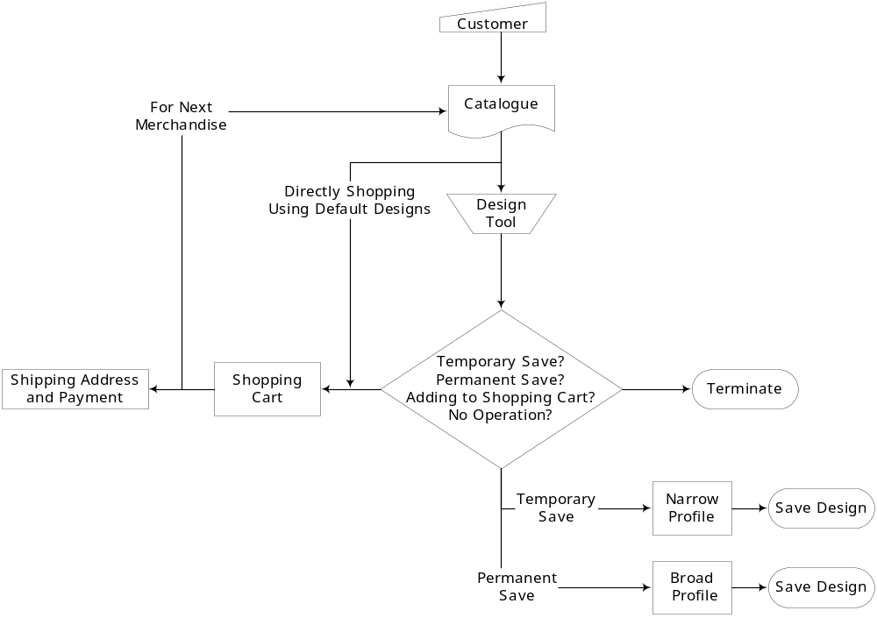

Catalogue Administration

- In the diagram below, shouldn’t the “Yes” be “No”? The process will terminate in case the merchandiser is not authenticated or after he completes defnining the merchandise.
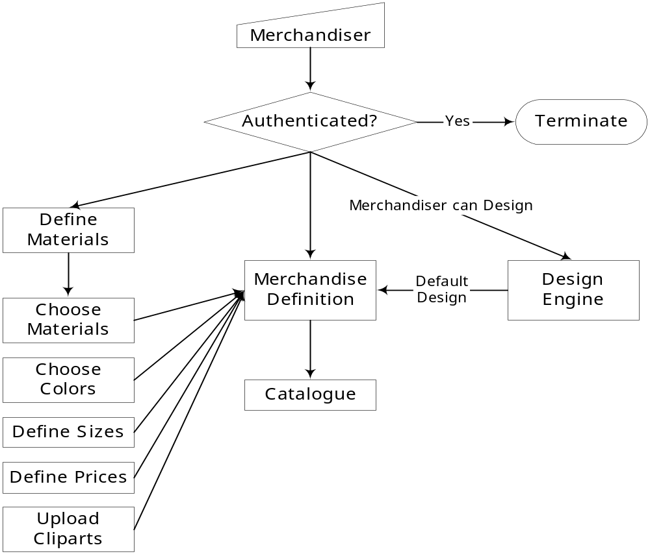

Design Engine
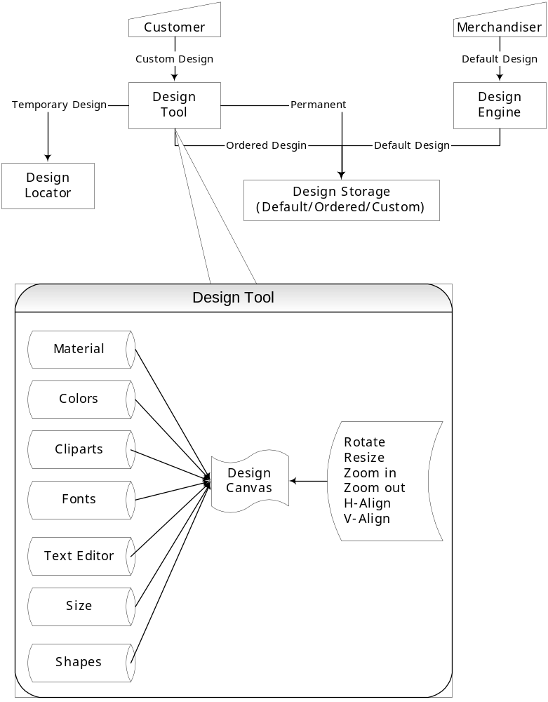

Operation and Back Office Management
[Order Verification]

- In diagram “Order Verification Type 2,” what did you mean by “Till Order Fulfillment”? The way I read this is: a customer order fails the verification in first cycle and after he/she is informed about the failure, he/she chooses to reorder after addressing the reasons why it failed in the first place. Let me know if this is the scenario for “Type 2”
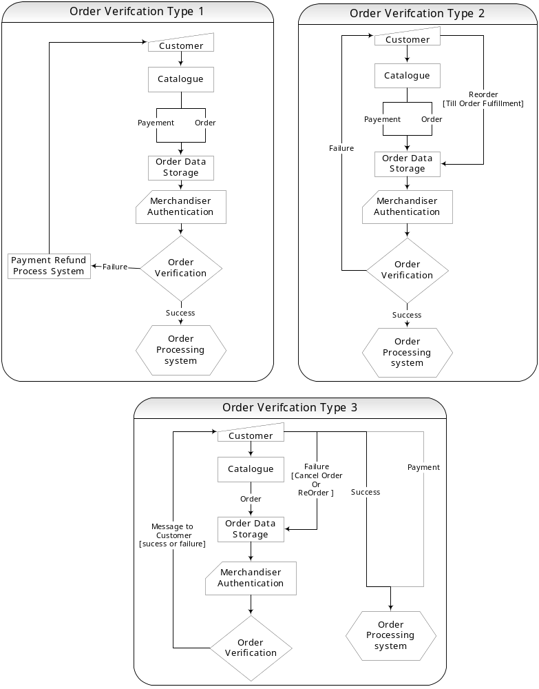

Operation and Back Office Management
[Order Processing]

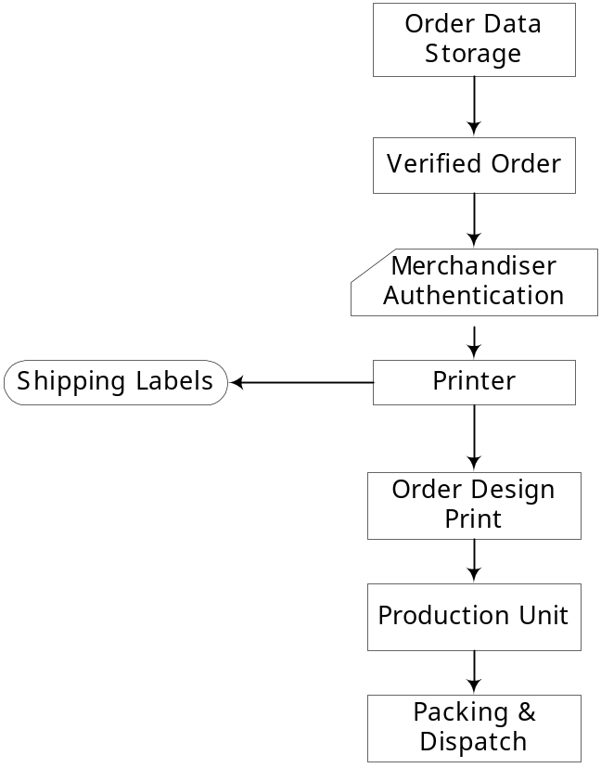

Packing and Dispatch

